Andrew Fulton

Max McDaniel

Carson Holt

Joseph Brakey

**CIS 560 Project: Team 22 - Blog**

**Introduction**

The system we designed was a barebones blogging website, with intended users being anyone and everyone on the internet (in theory). Users create an account and from there decide if they want to write articles as an Author or not. Authors are able to write and post articles, but all users are able to follow authors, favorite articles, and post comments.

**Technical Description**

Languages used include C#, HTML, and SQL. The bulk of the work was done in Microsoft Visual Studio.

**Database Design**

[Need updated database diagram (see project page on canvas for specific details)]

**System Design**

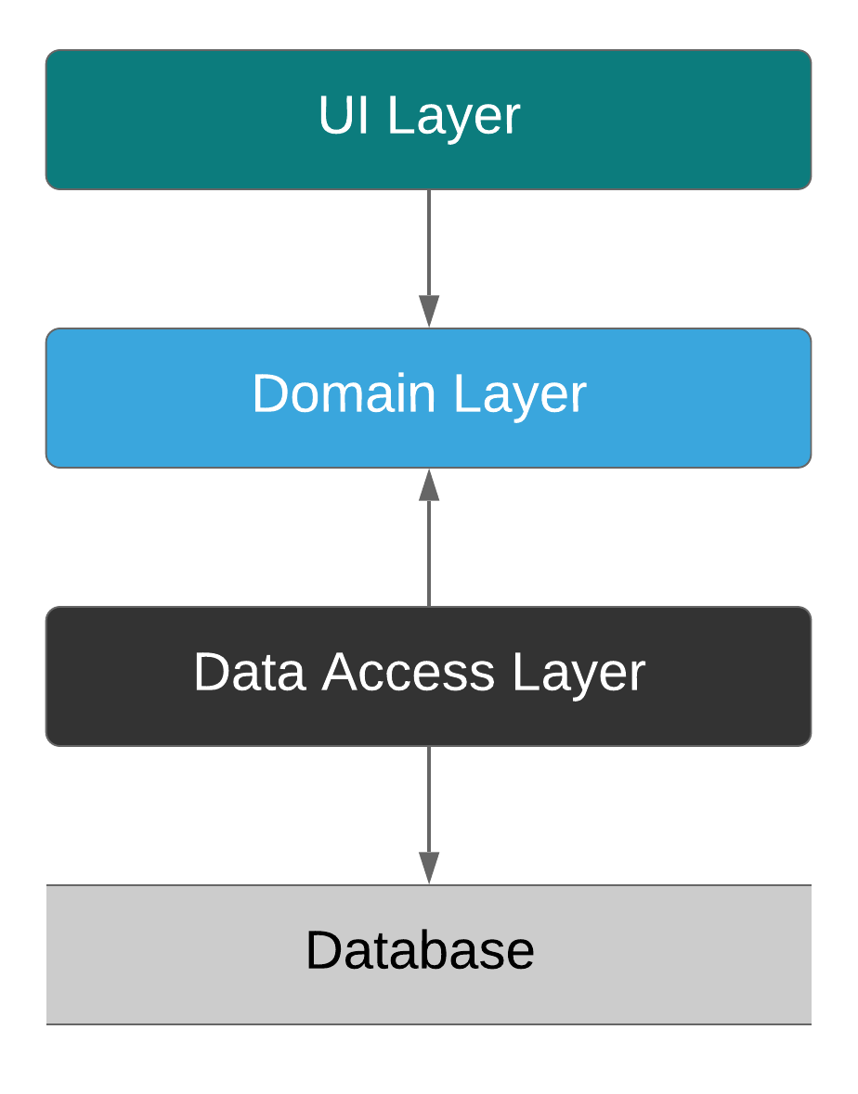

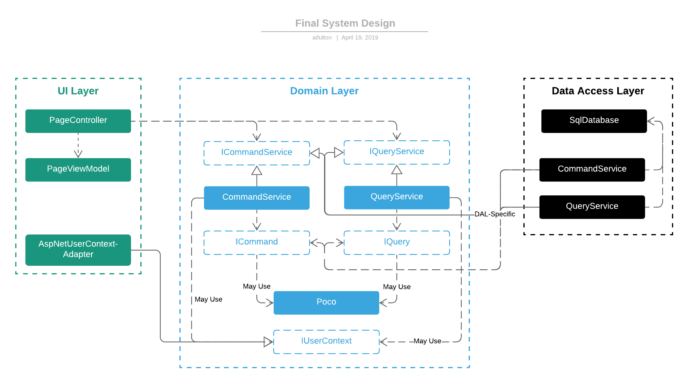

**System Features and Usage**

[Examples of interacting with system (with screenshots)]

**Report Queries**

[]

**Summary**

[]